Name: Katleho Esther

Surname: Makoane

Methodology for Bright Coffee Shop sales analysis

Objective: Provide actionable insights to the new CEO for improving sales performance and revenue growth using historical transactional date.

1. Project Overview

The Bright Coffee Shop dataset contains transactional records, including product type pricing, quantity sold, and timestamps. The new CEO is focused on increasing revenue and product performance. This project aims to uncover key insights using SQL, Excel, and data visualization techniques.

1. Tools & Technologies used

* Snowflake SQL ( Data transformation and querying)
* Microsoft Excel ( For Pivot charts, tables and dashboards)
* Canva ( For presenting final insights and recommendations)
* Miro (Planning architecture)

1. Data Processing Steps

* Initial Inspection
* The dataset was inspected for data quality issues such as inconsistent decimal formats (e.g. 3,1 vs 3.1) missing tine values, and non-numeric entries.
* Cleaning and standardization
* Converted unit_price from comma-formatted string (e.g. “3,1” ) to proper float (e.g. 3.1)

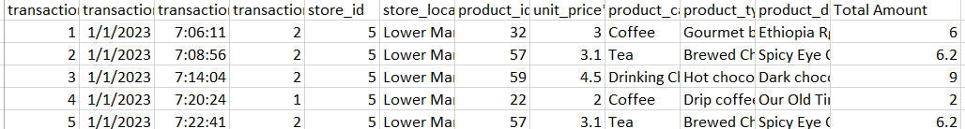

* Ensured all time fields were in standard date time format:

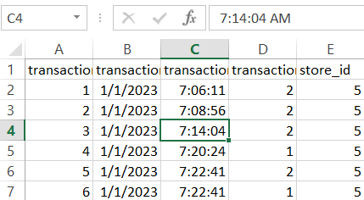

* Calculated a new column: total_amount = unit_price * transaction_qty

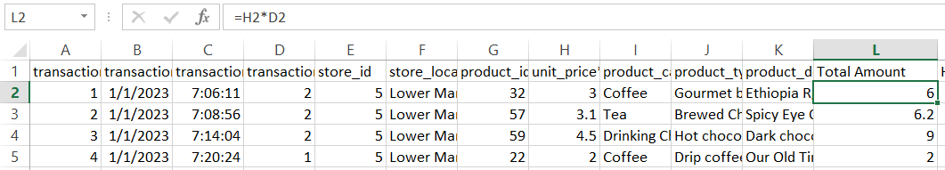

1. Data Analysis Approach
2. SQL Transformation in Snowflake

* Uploaded a cleaned data into Snowflake (CSV format).
* SQL queries performed:

Created a time bucket on Snowflake

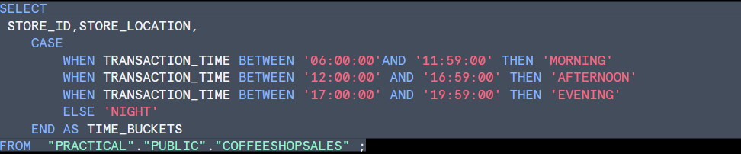

* Calculated total revenue by product type

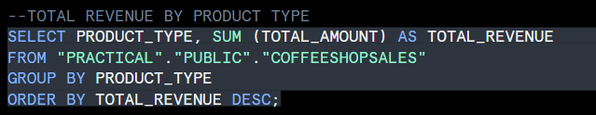

* Calculated Top-selling Product details

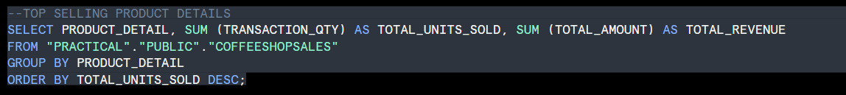

* Calculated sales by Time bucket

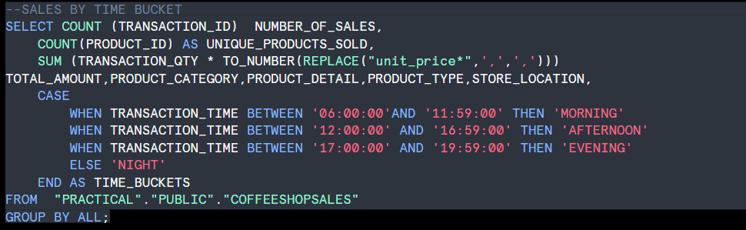

* Trend by date and Product type



1. Excel Dashboards & Pivot charts

* Used Pivot tables to summarize:
* Total revenue by product



* A pivot analysis was created in order to get the sum of total revenue by product type



* A line graph was created to sum up the total amount per product detail according to time bucket



* A pie chart was created to determine what sells more during the morning seeing that is the time that is mostly busy
* The pie chart was created using a pivot table

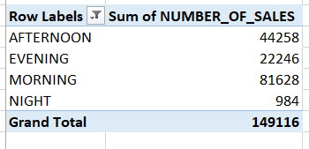

1. Key Insights Delivered

Top-Selling Products

* Most revenue generated by premium coffees. Organic, Lattes and Chocolate (Mostly Large sizes)
* Best-sellers were also top in volume, showing strong product-market fit.

1. Product category:

* Coffee and Tea dominate both revenue and volume
* Bakery products present strong upselling potential
* Some categories (e.g. Branded goods, Packaged Chocolate) had low traction

1. Next Steps

* Automate daily sales reporting using PowerBI or Excel
* Prepare combo deals increase sales on low-selling products
* Implement customer loyalty programs based on buying hours
* Periodically review underperforming items for replacement or building